Arduino Uno: It’s a simple computer, it is an open-source electronics platform easy-to-use hardware and software.

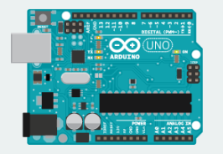

Battery Snap: It is used to connect a 9V battery to power leads that can be easily plugged into breadboard

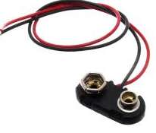

Breadboard: It is a board on which we can build electronic circuits. It’s like a patch, with rows of holes that allow us to connect wires and components together.

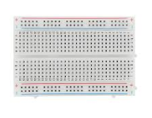

Capacitor consists of two conductors separated by a non-conductive region. When the circuit’s voltage is higher than what is stored in the capacitor, it allows current to flow in, giving the capacitor a charge. When the circuit’s voltage is lower, the stored charge is released. Often placed across power and ground close to a sensor to motor to help smooth fluctuations in voltage

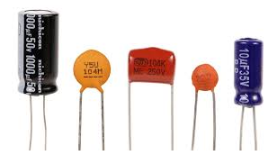

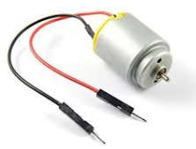

DC motors: It converts electrical energy into mechanical energy when electricity is applied to its leads. Coils of wire inside the motor become magnetized when current flows through them. These magnetic fields attract and repel magnets, causing the shaft to spin. If the direction of the electricity is reversed, the motor will spin in the opposite direction.

Diode: It ensures electricity only flows in one direction. Useful when we have a motor or other high current/ voltage load in our circuit. They allow current to pass through and on other way, they block it. the anode side connects to the point of higher energy in our circuit. The cathode connects to the point of lower energy, or to ground. The cathode is usually marked with a band on one side of the component’s body.

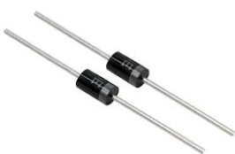

H-Bridge: An integrated circuit that allows us to control the polarity of the voltage applied to a load, usually a motor.

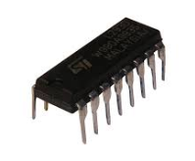

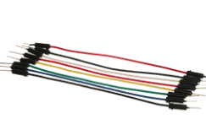

Jumper Wires: Use these to connect components to each other on the breadboard, and to the Arduino.

Light Emitting Diodes (LEDs): A type of diode that illuminates when electricity passes through it. Like all diodes, electricity only flows in one direction through these components. Anode connects to power (which is the longer leg) and the cathode is the shorter leg

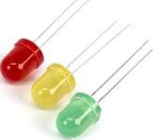

Liquid Crystal Display (LCD): A type of alphanumeric or graphic display based on liquid crystals, LCSs are available in a many sizes, shapes, and styles. (Basic 🡪 2 rows, 16 characters)

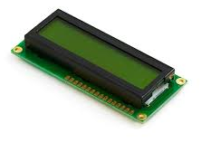

Male Header pins. These pins fit into female sockets, like those on a breadboard. They help make connecting things much easier

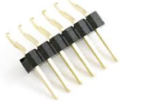

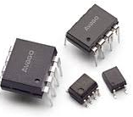

Optocouplers: this allows us to connect two circuits that do not share a common power supply internally there is a small LED that, when illuminated causes a photoreceptor inside to close an internal switch. When we apply voltage to the + pin, the LED lights and the internal switch closes. The two outputs replace a switch in the second circuit.

Piezo: An electrical component that can be used to detect vibrations and create noises.

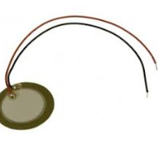

Photoresistor: It is also called a photocell, light-dependent resistor. A variable resistor that changes its resistance based on the amount of light that falls on its face.

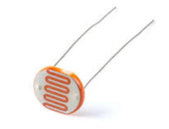

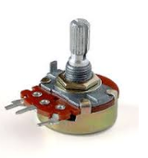

Potentiometer: A variable resistor with three pins. Two of the pins are connected to the ends of a fixed resistor. Th middle pin, or wiper, moves across the resistor, dividing it into two halves. When the external sides of the potentiometer are connected to voltage and ground, the middle leg will give the difference in voltage as we turn the knob. Often referred as a pot.

Pushbuttons: Momentary switch that close a circuit when pressed.

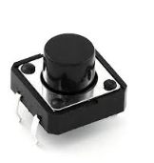

Resistors: Resist the flow of electrical energy in a circuit, changing the voltage and current as a result. Resistor values are measure in ohms

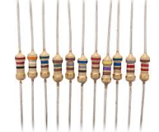

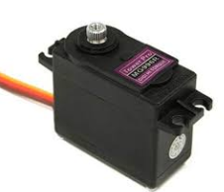

Servo Motor: A type of geared motor that can only rotate 180 degrees. It is controlled by sending electrical pulses from our Arduino. These pulses tell the motor what position is should move to.

Temperature sensor. Changes it voltage output depending on the temperature of the component. The outside legs connect to power and ground. The voltage on the center pin changes as it gets warmer or cooler.

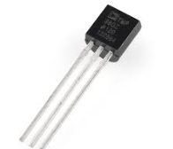

Tilt sensor: A type of switch that will open or close depending on its orientation. They are hollow cylinders with a metal ball inside that will make a connection across two leads when tilted in the proper direction.

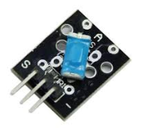

Transistor: A three-legged device that can operate as an electronic switch. Useful for controlling high current/high voltage components the motors. One pin connects to ground, another to the components being controlled, and the third connects to the Arduino. When the component receives voltage on the pin connected to an Arduino. It closes the circuit between the ground and the other component.

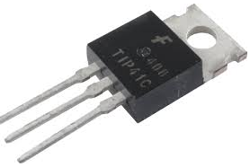

# Arduino Components

digitalRead(), digitalWrite(),

~analogWrite() + added bonus

Bootloader Blink

Indicates that our arduino is receiving power

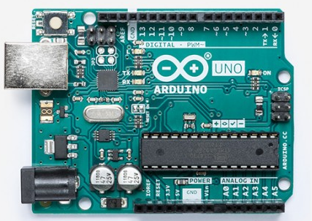

Reset

ATMEGA microcontroller

The heart

Receiving and Transmitting (communication). It blinks rapidly during sketch upload & serial communication

serial.println()

Upload codes

analogRead()

7-12V

GND

3V

5V

# Get to know

Electricity is a type of energy, much like heat, gravity, or light. electrical energy flows through conductors, like wire.

Transducers: It converts electrical energy into other forms of energy to do something interesting, like on a light or make some noise out of a speaker. The light bulbs or the speakers are electrical transducers. It changes other types of energy into electrical energy and vice-versa.

Sensors: Things that convert other forms of energy into electrical energy are called sensors.

Actuators: Things that convert electrical energy into other forms of energy.

Circuits: They are closed loops of wire with a power source (like a battery) and something to do something useful with the energy, called a load.

Flow of electricity: Electricity flows from a point of higher potential energy (+) to a point of point of lower potential energy (-).

Direct Current (DC): Electricity that flows only in one direction.

Alternating Current (AC): Electricity current direction alternates (50 to 60) times a second.

Current: It is the amount of electrical energy flowing past a specific point in our circuit.

Voltage: It is the difference in energy between one point in a circuit and another.

Resistance: Its is how much the component resists the flow of electrical energy.

* There needs to be a complete path from the energy source (power) to the point of least energy (ground) to make a circuit if there’s no path for the energy to travel, the circuit won’t work.
* Energy used up by the components in the circuit
* The flow of current at a specific point in a circuit will always be the same coming in and going out
* Electrical current will seek the path of least resistance to ground. Given two possible paths, more of the electrical current will go down the path with less resistance.

Short Circuit: When we have a connection that connects power and ground together with no resistance. The power source and wires convert the electrical energy into light and heat, usually as sparks as an explosion.

The five holes in each horizontal row are connected electrically through metal strips inside the breadboard. The middle row breaks the connection between the two sides of the board.

The middle row breaks connection between the two sides of the board. The vertical strips that run the length of the breadboard are electrically connected.

The strips are usually used for power and ground connections.

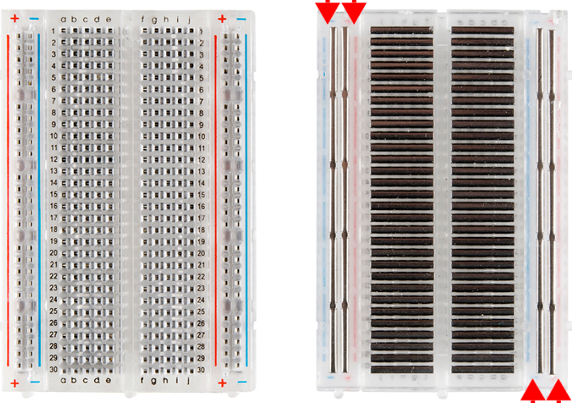

Multimeter: It is a tool that can verify the amount of resistance, current and voltage in our circuit

Series Circuit

Components in series come one after another

Parallel Circuit

Components in parallel run side by side

Ohms law = V = I * R

Four Band/ Five Band Resistors

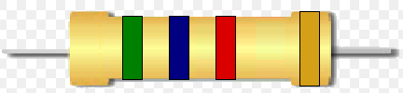

1st digit, 2nd digit, multiplier, tolerance

Black, Brown, VBGYOR, Grey, White

1st, 2nd, 3rd (5 band), Multipliers only (0 to 6)

|  |  |
| --- | --- |
| 0 |  |
| 1 |  |
| 2 |  |
| 3 |  |
| 4 |  |
| 5 |  |
| 6 |  |
| 7 |  |
| 8 |  |
| 9 |  |

Digits

|  |  |
| --- | --- |
| 0 |  |
| 1 |  |
| 2 |  |
| 3 |  |
| 4 |  |
| 5 |  |

|  |  |
| --- | --- |
| Brown | 1% |
| Red | 2% |
| Gold | 5% |
| Silver | 10% |

Multiplier

Tolerance

# Get to sketch code

Arduino’s digital pins can read only two states, when there is voltage on an input pin, and when there’s not. Therefore, HIGH means it has voltage in the pin. LOW means no voltage in the pin.

digital

Every Arduino program has two main functions. Functions are parts of a computer program that run specific commands. The necessary functions in Arduino are setup() and loop().

To create a variable, we need declare its type. Therefore,

int switchState = 0;

In **setup()** is where we configure the digital pins to the either inputs or outputs using a function named **pinMode()**. We define whether the pin should be **INPUT** or **OUTPUT.**

In **loop(),** It runs continuously after the setup() has completed. this is where we can use **digitalRead(), digitalWrite(), analogRead(), analogWrite()**

They all take arguments

# Spaceship

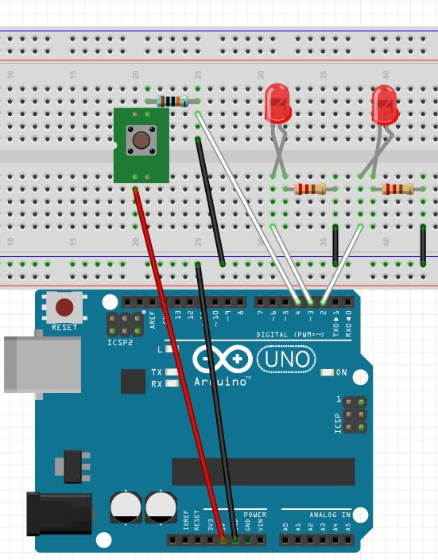

1. int switchState = 0;
2. void setup() {
3. pinMode(2, INPUT);
4. pinMode(3, OUTPUT);
5. pinMode(4, OUTPUT);
6. }
7. void loop() {
8. switchState = digitalRead(2);
9. if (switchState == LOW) {
10. digitalWrite(3, HIGH);
11. digitalWrite(4, LOW);
12. } else {
13. delay(250);
14. digitalWrite(3, LOW);
15. digitalWrite(4, HIGH);
16. delay(250);
17. digitalWrite(3, HIGH);
18. digitalWrite(4, LOW);
19. }
20. }

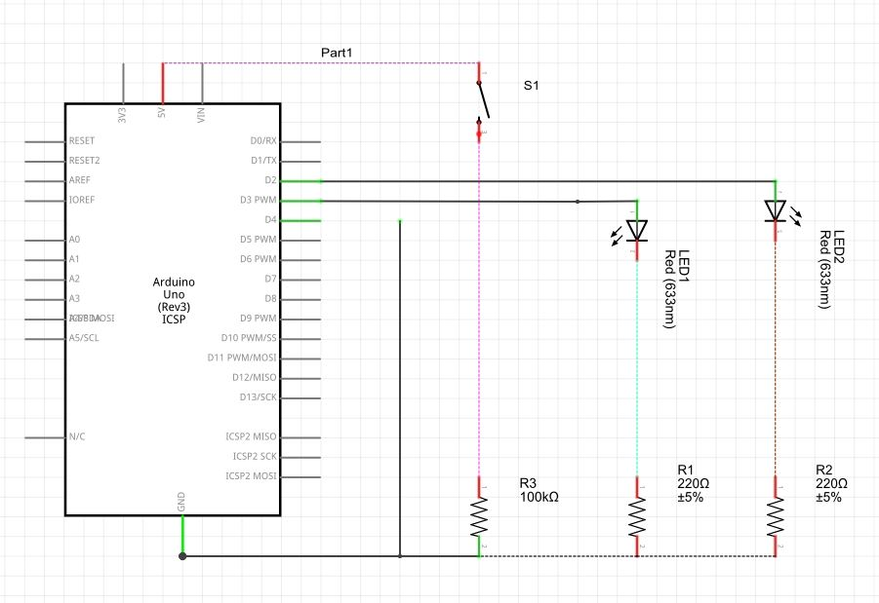

1. int switchState = 0;
2. void setup() {
3. pinMode(2, INPUT);
4. pinMode(3, OUTPUT);
5. pinMode(4, OUTPUT);
6. }
7. void loop() {
8. switchState = digitalRead(2);
9. if (switchState == LOW) {
10. digitalWrite(3, HIGH);
11. digitalWrite(4, LOW);
12. } else {
13. delay(250);
14. digitalWrite(3, LOW);
15. digitalWrite(4, HIGH);
16. delay(250);
17. digitalWrite(3, HIGH);
18. digitalWrite(4, LOW);
19. }
20. }

# PHP Communication

**PHP CODE**

1. <? php // exec("#96;mode COM3: BAUD=115200 PARITY=N data=8 stop=1 XON=off TO=on &#96");
2. if (isset($_GET['confirm'])): try {
3. $fp = fopen('COM3', 'w');
4. fwrite($fp, $_GET['serial']);
5. sleep(2);
6. } catch (Exception $e) {
7. echo $e - > getMessage();
8. } finally {
9. fclose($fp);
10. }
11. endif; ?> < form method = 'GET'
12. action = "<?php echo $_SERVER['PHP_SELF']; ?>" > < input type = 'text'
13. name = 'serial' / > < input type = 'submit'
14. name = 'confirm'
15. value = 'Send' / > < /form>

**Arduino Code**

1. int  serialRead;
2. int  reset;
3. void  setup()  {
4. Serial.begin(9600);
5. pinMode(2,  INPUT);
6. pinMode(3,  OUTPUT);
7. pinMode(4,  OUTPUT);
8. }
9. void  loop()  {
10. if  (Serial.available()  >  0)  {
11. serialRead  =  Serial.read();
12. if  (serialRead  ==  49)  {
13. for  (int  i  =  0;  i  <  10;  i++)  {
14. delay(250);
15. digitalWrite(3,  HIGH);
16. digitalWrite(4,  LOW);
17. delay(250);
18. digitalWrite(3,  LOW);
19. digitalWrite(4,  HIGH);
20. reset  =  digitalRead(2);
21. if  (reset  ==  HIGH)  {
22. break;
23. }
24. }
25. digitalWrite(3,  LOW);
26. digitalWrite(4,  LOW);
27. }
28. else  if  (serialRead  ==  50)  {
29. for  (int  i  =  0;  i  <  10;  i++)  {
30. delay(250);
31. digitalWrite(3,  HIGH);
32. digitalWrite(4,  HIGH);
33. delay(250);
34. digitalWrite(3,  LOW);
35. digitalWrite(4,  LOW);
36. reset  =  digitalRead(2);
37. if  (reset  ==  HIGH)  {
38. break;
39. }
40. }
41. digitalWrite(3,  LOW);
42. digitalWrite(4,  LOW);
43. }
44. }
45. }





# Potentiometer

From A0 to A5 PIN, it can be only used to read the analog reading, Arduino’s smart analog to digital converter with pulse modulation allows to give reading between 0 to 1023 which maps (0 to 5V)

* Place the rounded part of the temperature sensor away from the Arduino. Connect the left most pin to the power and read the right most pin to the ground. The center pin goes the reading INPUT (A0 to A5)
* To convert the digital value to actual

1. float readingValue;
2. float voltage;
3. float temperature;
4. void setup() {
5. Serial.begin(9600);
6. for (int pinNumber = 3; pinNumber < 5; pinNumber++) {
7. pinMode(pinNumber, OUTPUT);
8. digitalWrite(pinNumber, LOW);
9. }
10. }
11. void loop() {
12. readingValue = analogRead(A0);
13. voltage = (readingValue / 1024) * 5;
14. if (voltage > 3 && voltage < 4) {
15. digitalWrite(3, HIGH);
16. digitalWrite(4, LOW);
17. delay(250);
18. digitalWrite(3, LOW);
19. digitalWrite(4, HIGH);
20. delay(250);
21. } else if (voltage > 4 && voltage < 5) {
22. digitalWrite(3, HIGH);
23. digitalWrite(4, HIGH);
24. delay(250);
25. digitalWrite(3, LOW);
26. digitalWrite(4, LOW);
27. delay(250);
28. } else if (voltage > 2 && voltage < 3) {
29. digitalWrite(4, HIGH);
30. delay(250);
31. digitalWrite(4, LOW);
32. delay(250);
33. } else if (voltage > 1 && voltage < 2) {
34. digitalWrite(3, HIGH);
35. delay(250);
36. digitalWrite(3, LOW);
37. delay(250);
38. } else {
39. digitalWrite(3, LOW);
40. digitalWrite(4, LOW);
41. }
42. Serial.println(voltage);
43. delay(1000);
44. }

